

**STAFF MANAGEMENT SYSTEM**

**MINI PROJECT REPORT**

Submitted by:

**Manojkumar M - 231801097**

**Mohit Krishna A-(231801110)**

CS23333 OBJECT ORIENTED PROGRAMMING USING JAVA

Department of Artificial Intelligence and Data Science

Rajalakshmi Engineering College, Thandalam

**2024-2025**

**BONAFIDE CERTIFICATE**

Certified that this project report “**STAFF MANAGEMENT SYSTEM**” is the bonafide work of **“MANOJ KUMAR(231801097) , MOHIT KRISHNA(231801110) ”**

who carried out the project work under my supervision.

**Submitted for the Practical Examination held on**

**SIGNATURE SIGNATURE**

|  |  |  |  |  |
| --- | --- | --- | --- | --- |
| **Dr. GNANASEKAR J M** | **Ms.Renukha Devi** | **Dr.GNANASEKAR J M** | **Dr. MANORANJINI J** | **Dr.MANORANJINI J** |
| **Head of the Department, Artificial intelligence**  **and data Science, Rajalakshmi Engineering College (Autonomous),Chennai-602105** | **Assoc.Professor, Artificial Intelligence and Data**  **Science, Rajalakshmi Engineering College (Autonomous), Thandalam, Chennai-602105** | |  | | --- | | **Head of the Department, Artificial intelligence**  **and data Science,Rajalakshmi Engineering College (Autonomous),Chennai-602105** | | **Professor, Artificial Intelligence and Data**  **Science, Rajalakshmi Engineering College (Autonomous), Thandalam, Chennai-602105** | **Associate Professor, Artificial Intelligence and Data Science, Rajalakshmi Engineering College,(Autonomous), Thandalam, Chennai-602105** |

**INTERNAL EXAMINER EXTERNAL EXAMINER**

**TABLE OF CONTENT**

|  |  |  |
| --- | --- | --- |
| **S.NO** | **CHAPTER** |  |
| 1. | **INTRODUCTION** |  |
| 1.1 | GENERAL |  |
| 1.2 | OBJECTIVES |  |
| 1.3 | SCOPE |  |
| 2. | **SYSTEM OVERVIEW** |  |
| 2.1 | SYSTEM ARCHITECTURE |  |
| 2.2 | MODULES OVERVIEW |  |
| 2.3 | USER ROLES AND ACCESS LEVELS |  |
| 3. | **SURVEY OF TECHNOLOGIES** |  |
| 3.1 | SOFTWARE AND TOOLS USED |  |
| 3.2 | PROGRAMMING LANGUAGES |  |
| 3.3 | FRAMEWORKS AND LIBRARIES |  |
| 4. | **REQUIREMENTS AND ANALYSIS** |  |
| 4.1 | FUNCTIONAL REQUIREMENTS |  |
| 4.2 | NON-Functional Requirements |  |
| 4.3 | HARDWARE AND SOFTWARE REQUIREMENTS |  |
| 4.4 | ARCHITECTURE DIAGRAM |  |

|  |  |  |  |
| --- | --- | --- | --- |
| 5. | **SYSTEM DESIGN** | |  |
| 5.1 | DATABASE DESIGN AND TABLES | |  |
| 5.2 | UI DESIGN OVERVIEW | |  |
| 5.3 | WORKFLOW AND PROCESS DIAGRAMS | |  |
| 6. | **IMPLEMENTATION** | |  |
| 6.1 | CODE STRUCTURE AND ORGANIZATION | |  |
| 6.2 | KEY MODULES AND THEIR FUNCTIONS | |  |
| 6.3 | CHALLENGES AND SOLUTIONS | |  |
| 7. | **TESTING AND VALIDATION** | |  |
| 7.1 | TESTING STRATEGIES | |  |
| 7.2 | TEST CASES AND RESULTS | |  |
| 7.3 | BUG FIXES AND IMPROVEMENTS | |  |
| 8. | **RESULTS AND DISCUSSION** | |  |
| 8.1 | SUMMARY OF FEATURES | |  |
| 8.2 | USER EXPERIENCE FEEDBACK | |  |
| 8.3 | POTENTIAL IMPROVEMENTS | |  |
| 9 | **CONCLUSION** | |  |
| 10 | **REFERENCES** |  | |

## ABSTRACT

**The Faculty Management System is a web-based application designed to simplify the management of faculty-related tasks in educational institutions. It enables administrators and faculty to efficiently manage faculty records, assign courses, track schedules, and monitor performance. With features like data management, course assignments, and performance tracking, the system enhances coordination and decision-making. Developed using modern web technologies, it offers a user-friendly interface and secure backend for data protection. Visual tools, such as dashboards and reports, provide valuable insights into faculty performance and workload, helping administrators improve administrative efficiency and support faculty development for a more effective academic environment.**

**1. INTRODUCTION**

* 1. **General**

**This report details the development of a comprehensive Faculty Management System designed to streamline the administration and management of faculty-related activities within educational institutions. With the increasing complexity of faculty responsibilities and the need for efficient coordination, this system aims to provide an organized and systematic approach to managing faculty data, schedules, and performance. Through the use of structured design principles and effective code implementation, the system delivers an intuitive, user-friendly experience that supports academic institutions in optimizing faculty operations.**

**The Faculty Management System addresses common challenges faced in faculty administration, such as managing teaching schedules, tracking academic performance, and maintaining up-to-date records. By utilizing a web-based interface, the system allows administrators and faculty members to easily access and manage vital information, including course assignments, leave records, and professional development activities. Designed to cater to a diverse range of users, from department heads to individual faculty members, this system emphasizes usability and accessibility, ensuring an efficient and streamlined approach to managing faculty-related tasks.**

**1.2 Objectives**

The main objectives of the Faculty Management System are:

• Faculty Data Management: Develop a system that efficiently stores and manages comprehensive faculty information, including personal details, academic qualifications, and teaching experience, ensuring easy access and accurate record-keeping.

• Schedule and Course Assignment Management: Provide an intuitive interface for administrators to assign courses, manage teaching schedules, and track faculty availability, ensuring optimal use of resources and minimizing scheduling conflicts.

• Performance Monitoring and Reporting: Generate detailed performance reports that allow administrators and faculty members to assess academic contributions, track professional development, and identify areas for improvement.

In addition to these objectives, the system aims to support effective decision-making by providing insights into faculty workload distribution, performance trends, and other key metrics, enabling continuous improvement in faculty management practices.

**1.3 Scope**

**The scope of the Faculty Management System encompasses a range of features designed to efficiently manage faculty data and improve administrative processes. The system enables users to:**

**• Manage Faculty Records: Store and categorize detailed faculty information, such as personal details, academic qualifications, teaching experience, and certifications, allowing for easy updates and accurate record-keeping.**

**• Schedule and Course Management: Administrators can assign courses to faculty members, manage teaching schedules, and track availability, ensuring optimal course allocation and minimizing conflicts.**

**• Faculty Performance Monitoring: Track faculty performance metrics, including teaching evaluations, research contributions, and professional development, enabling administrators to generate reports and assess performance trends.**

**Beyond basic record management, the system also includes features such as the ability to filter faculty data by department, position, or performance metrics, allowing for deeper analysis of faculty performance across different criteria. This functionality supports administrators in making data-driven decisions, such as adjusting workloads or providing targeted professional development opportunities.**

**Extended Functionalities and Future Enhancements**

**In the long term, the system can be enhanced to include features such as automated faculty evaluation systems, integration with learning management platforms for tracking course progress, and tools for managing faculty leave and attendance. Additionally, integration with external systems such as HR or payroll databases could streamline faculty compensation and benefits management, further improving operational efficiency.**

**2. SYSTEM OVERVIEW**

**System Architecture**

**The Faculty Management System is designed using a three-tier architecture that ensures efficient data processing, organized management, and enhanced security. This architecture consists of three main layers:**

**• Front-End Interface :The front-end is the user-facing component, providing an interactive web-based interface through which administrators and faculty can perform essential actions like managing faculty records, assigning courses, tracking schedules, and viewing performance data. This layer is designed with a focus on simplicity and ease of use, offering a responsive interface that adapts to various devices, ensuring accessibility on desktops, tablets, and mobile phones.**

**• Middle Layer (Data Processing): The middle layer serves as the logic core of the system, handling all data processing tasks. It bridges the front-end and the backend by managing business logic, processing requests, and validating data. For example, when a user updates a faculty record or generates a performance report, the middle layer ensures that these actions are processed smoothly and efficiently. This layer also uses RESTful APIs to facilitate scalable data processing and integration with other systems, such as HR or payroll databases, for seamless data exchange.**

**• Backend Database: The backend is the storage layer where all faculty data is securely maintained. It uses a relational database management system (RDBMS) to store, retrieve, and manage data efficiently. The database is structured to store faculty information, course assignments, performance records, and schedule details. Security measures such as encryption, role-based access controls, and user authentication ensure that sensitive data is protected from unauthorized access.**

**This three-tier architecture ensures modular development, ease of maintenance, and scalability, allowing for updates or changes to one layer without disrupting the overall functionality of the system. This design approach provides a flexible and secure foundation for efficient faculty management.**

**2.2 Modules Overview**

**The Faculty Management System is composed of several key modules, each serving a specific function to facilitate the management of faculty-related tasks. The primary modules include:**

**• Faculty Record Management: This module allows administrators to add, edit, and manage faculty records, including personal details, academic qualifications, and teaching history. Faculty information can be organized into different categories, such as departments or positions, to provide a comprehensive overview. Additionally, this module supports the management of faculty availability and leave records, ensuring accurate and up-to-date information is maintained.**

**• Course and Schedule Management: This module enables administrators to assign courses to faculty members, manage teaching schedules, and ensure there are no conflicts. Faculty can view their schedules, course assignments, and availability in real-time. The system also allows for adjustments in case of last-minute changes, offering an intuitive interface for both administrators and faculty members to manage their time and resources effectively.**

**• Performance and Reporting: The reporting module generates detailed performance reports for faculty members based on various criteria such as teaching evaluations, course completion rates, and professional development activities. Users can filter reports by date, department, or specific faculty member. Visual tools such as charts and graphs present this data clearly, aiding administrators in evaluating faculty performance and making informed decisions. Reports can also be exported in various formats, such as PDF or CSV, for further analysis or record-keeping.**

**• Data Management: Responsible for handling all data storage, retrieval, and updates, the data management module ensures efficient communication between the front-end and back-end. Built using Java, it handles SQL queries to fetch and update data quickly, maintaining smooth system performance. This module also includes data validation mechanisms to ensure consistency and accuracy. Additionally, it supports data backup features to prevent loss, ensuring the integrity of faculty records and schedules.**

**These modules, developed using Java for both the front-end and back-end, work together to create a cohesive and efficient Faculty Management System that simplifies the administration of academic institutions while improving overall operational efficiency.**

**2.3 User Roles and Access Levels**

**The Faculty Management System is designed to accommodate multiple user roles with varying levels of access, ensuring that different users can perform specific tasks based on their responsibilities. The system includes the following key roles:**

**• Administrator: Administrators have full access to all aspects of the system, including managing faculty records, assigning courses, tracking performance, and generating reports. They can also configure user roles and access permissions, making them the primary user of the system for overall management and oversight.**

**• Faculty Members :Faculty members have access to their own records, schedules, course assignments, and performance reports. They can update their personal information, view their teaching assignments, and track their own professional development activities. Faculty members are restricted from accessing other users' records, ensuring privacy and data security.**

**• Department Heads: Department heads have access to the records and schedules of faculty within their department. They can view and manage course assignments, monitor faculty performance, and generate reports related to their department. However, they do not have full administrative privileges and cannot alter the system configuration.**

**Access to the backend database is restricted to authenticated users only, preventing unauthorized access to sensitive data. The system is designed with Java for both the front end and back end, ensuring secure and seamless role-based access management.**

**While the current version of the system is designed to support multiple user roles, it is built with scalability in mind. Future versions of the system could include additional roles, such as HR staff or academic advisors, and provide more granular access control, allowing for a more customizable and secure user experience.**

Additionally, secure authentication protocols are in place to protect user data from unauthorized access, making the system robust even in its single-user configuration.

**2.4 Potential Enhancements for User Access**

As a potential enhancement, the Faculty Management System could introduce more granular multi-user access levels, accommodating various roles with different permissions. These roles might include "Administrator," "Department Head," "Faculty Member," and "Guest."

• The Administrator role would have full access to all features of the system, such as managing faculty records, assigning courses, generating performance reports, and configuring user access levels. Administrators would also be able to modify system settings and oversee data integrity.

• The Department Head role could provide access to faculty records and performance data specific to their department, allowing them to monitor schedules, course assignments, and faculty evaluations, but without the ability to alter system-wide settings.

• The Faculty Member role would be restricted to managing and viewing their own records, courses, and performance metrics, ensuring privacy and security.

• The Guest role could be used to grant limited, view-only access to specific reports, making it easier to share information with external stakeholders, such as academic auditors or external reviewers, without compromising sensitive data.

This modular design, combined with Java-based development for both the front end and back end, ensures that the system can be easily extended to accommodate these roles. By supporting customizable user access, the system can evolve to meet the changing needs of the institution, providing a scalable and secure solution for managing faculty data over time.

**3. SURVEY OF TECHNOLOGIES**

**3.1 Software and Tools Used**

3.1 Software and Tools Used

The development of the Faculty Management System incorporates a range of programming languages, tools, and frameworks that support both front-end and back-end development. The primary components of the system include:

• Java: Used as the core language for both front-end and back-end development, enabling seamless integration between the user interface and the server-side logic. Java is responsible for handling business logic, processing user requests, and interacting with the database.

• SQL: Employed for managing structured data storage, SQL ensures efficient querying and manipulation of faculty-related data, supporting the system's functionality.

• JavaFX: Used for developing the front-end user interface, JavaFX offers a rich, interactive, and responsive experience for users, ensuring smooth navigation and usability.

The system is built on a Java-based architecture, with both front-end and back-end components closely integrated to deliver a robust and efficient solution for managing faculty-related processes.

**3.2 Programming Languages**

The Faculty Management System utilizes a set of programming languages, each playing a key role in delivering a cohesive and efficient application:

• Java: Java serves as the primary language for both the front-end and back-end of the system. For the front-end, Java provides a rich and interactive user interface through JavaFX, enabling smooth navigation and responsiveness. On the back-end, Java handles business logic, manages user requests, and facilitates communication with the database, ensuring smooth and efficient data flow throughout the system.

• SQL: SQL is used for database management, allowing for efficient data storage, retrieval, and manipulation of faculty records. Through SQL queries, the system ensures that faculty data is accurately stored and updated, supporting functionalities such as adding, editing, and searching faculty information.

• JavaFX: JavaFX is utilized to develop the user interface, offering a responsive and interactive experience. It supports the creation of intuitive layouts and dynamic user interactions, enhancing usability and providing a smooth front-end experience for managing faculty details.

The use of Java across both the front-end and back-end ensures consistency, performance, and scalability within the Faculty Management System, while SQL provides efficient data handling capabilities.

**3.3 Frameworks and Libraries**

To streamline development and enhance functionality, the **Faculty Management System** integrates several tools and libraries to support both front-end and back-end operations, with Java being the core language for both:

• JavaFX: JavaFX serves as the primary framework for building the front-end user interface of the Faculty Management System. It provides a rich set of GUI components, allowing developers to create a dynamic, responsive, and visually appealing interface. JavaFX's integration with Java ensures smooth communication between the front-end and back-end, enabling a seamless user experience. With its support for multimedia, animations, and various UI elements, JavaFX enhances the overall usability of the system.

• JDBC (Java Database Connectivity): JDBC is used to manage database operations within the system. It allows the Faculty Management System to interact with the database using Java code, enabling efficient data retrieval, insertion, and updates. JDBC abstracts the complexities of direct SQL commands and provides a standardized interface for database connectivity. This approach ensures that the system can handle large amounts of faculty-related data securely and efficiently, while also mitigating common risks like SQL injection.

These frameworks and tools provide a robust and scalable foundation for the Faculty Management System, ensuring that both front-end and back-end processes are tightly integrated. By leveraging JavaFX for the UI and JDBC for data management, the system offers a seamless, user-friendly experience while maintaining powerful back-end capabilities. This structure also sets the stage for future enhancements and scaling of the application.

**4. REQUIREMENTS AND ANALYSIS**

4.1 Functional Requirements

- The **Faculty Management System** should enable users to add, view, update, and delete faculty records, including personal details, department affiliation, and contact information.

- The system must support generating reports based on various criteria, such as faculty department, age, status, or other relevant filters.

- Users should be able to search for specific faculty members by name, department, or contact details.

- The system should allow administrators to update faculty records, including modifying personal and departmental information, and handle employee status updates (e.g., active, retired, on leave).

4.2 Non-Functional Requirements

- **Performance**: The application should be highly responsive, ensuring quick load times and smooth navigation throughout the system, particularly when accessing or updating faculty records.

- **Data Security**: The application must implement robust security measures to protect sensitive faculty data. This includes encrypted communication (using SSL/TLS), secure login authentication, and authorization controls to restrict access to different features based on user roles (e.g., admin, user).

- **Usability**: The user interface must be intuitive and easy to use, with clear navigation paths for adding, editing, and viewing faculty information. The system should also be accessible on different devices and screen sizes.

4.3 Hardware and Software Requirements

- Hardware: The system can run on a standard PC or server, with internet access for web-based operations. A minimum of 4GB of RAM and a multi-core processor is recommended for smooth performance.

- Software:

- Java: The Faculty Management System uses Java for both front-end (JavaFX) and back-end (Java) development.

- Database: A SQL-based database (such as MySQL or MariaDB) is required to store faculty information and user data securely.

- Web Browser: A modern web browser (such as Google Chrome, Mozilla Firefox, or Safari) is needed for accessing the system through its user interface.

- IDE/Development Tools: Java development tools like NetBeans or Eclipse for building, testing, and debugging the application.

This set of requirements ensures that the Faculty Management System will function effectively, maintain high performance, and provide a secure environment for managing faculty data. The system is designed to be scalable, efficient, and user-friendly, with the flexibility to support future enhancements and additional features.

**4.5 ER Diagram**

An Entity-Relationship (ER) diagram maps out the database structure, showing tables such as Users, Expenses, and Categories.

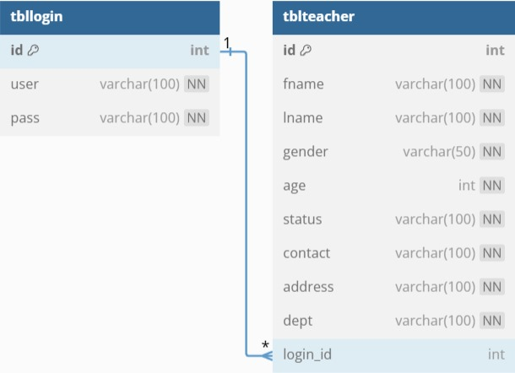

**Fig. 2. ER Diagram**

**5. SYSTEM DESIGN**

5.1 Database Design and Tables

The Faculty Management System uses a relational database to manage faculty information, user credentials, and other relevant data. The system is structured around the following tables:

- Users: This table stores login credentials, including usernames and passwords for administrators and users of the system.

- Faculty: This table contains details about each faculty member, including their first name, last name, gender, age, marital status, contact information, and department.

- Departments: This table lists the different departments available in the system, such as IT, Education, and Criminal Justice.

- Roles: The Roles table defines the different user roles (e.g., admin, regular user), ensuring proper access control throughout the system.

- Reports: This table holds data regarding generated reports, tracking parameters like date range, category, and type of report (e.g., faculty details by department).

Each table is designed to ensure efficient data retrieval and updates, using primary keys for unique identification and foreign keys for linking related data across tables (e.g., linking faculty members to departments). The database structure is optimized for quick querying and updates while maintaining data integrity and security.

5.2 UI Design Overview

The Faculty Management System UI follows a clean, minimalist design that prioritizes ease of use and efficient navigation. The main interface is intuitive and user-friendly, with clear navigation menus that lead users to different sections of the system. The design includes:

- Navigation Bar: A fixed navigation bar at the top of the page provides easy access to key sections, such as:

- Dashboard: A quick overview of faculty statistics and system updates.

- Add Faculty: A form to add new faculty members to the system.

- Faculty List: A page where users can view, search, and filter faculty records.

- Reports: A section dedicated to generating and viewing reports based on various criteria like department, status, or age.

- Responsive Layout: The UI is responsive, ensuring that the system works seamlessly on different devices, including desktops, tablets, and smartphones. Each page is designed for optimal viewing, minimizing the need for excessive scrolling or resizing.

5.3 Workflow and Process Diagrams

The Faculty Management System follows a straightforward process flow for users to interact with the application. The key steps in the workflow include:

1. Login: Users log into the system with their credentials (username and password). Based on their role, they are granted access to specific parts of the system.

2. Faculty Management:

- Add Faculty: Administrators can add new faculty members by entering their details into a form.

- View/Edit Faculty: Users can search, view, and update faculty details. This includes editing personal information, departmental assignments, and faculty status.

3. Reports: Users can generate reports based on filters such as department, status, or age. Reports are generated dynamically and can be viewed or exported for further analysis.

4. Logout: Once tasks are completed, users can log out to ensure their session is securely closed.

This workflow ensures a streamlined and user-friendly experience for all system users, from administrators to regular users, while maintaining security and data integrity.

**6. IMPLEMENTATION**

6.1 Code Structure and Organization

The **Faculty Management System** is structured in a modular way to enhance code readability, maintainability, and scalability. Each part of the application is divided into separate files and directories, with clear separation of concerns. This modular approach makes the codebase easier to debug, test, and extend, as new features or changes can be made without disrupting other parts of the system.

The codebase is organized as follows:

- Application Folder: This folder contains the main Java application files, including the entry point to the system. It is responsible for managing user authentication, routing, and coordinating data flow between the front-end (JavaFX) and the back-end (Java). It handles the communication between the user interface and the business logic.

- Model Folder: This folder contains Java classes that define the core objects and data models for the system, such as `Faculty`, `Department`, and `User`. These classes are responsible for interacting with the database and holding the data for the application. Each model represents a specific part of the system, ensuring a clean and logical separation of functionality.

- Controller Folder: This folder holds the classes responsible for handling the business logic. It manages user input, processes data, and communicates with the model layer to perform actions like adding, updating, or deleting faculty records. The controller is responsible for orchestrating the flow of data between the user interface and the model.

- View Folder: The JavaFX front-end user interface is placed in this folder. It contains all the UI components, such as forms, buttons, and tables, that users interact with. JavaFX controllers in this folder handle the user interface elements, listening for events (e.g., button clicks) and triggering the corresponding actions in the controllers.

- Database Configuration: Contains Java classes that manage the database connection, including **JDBC** setup and database queries. These classes handle data retrieval and storage operations for the system, ensuring smooth interaction with the underlying database.

- Resources Folder: This folder contains resources such as configuration files, images, CSS files, and JavaScript files (if any). These files are used to style the user interface and provide additional functionality like form validation or interactive elements.

The main entry point for the Faculty Management System is the Java class in the Application Folder, which initializes the system and launches the JavaFX interface. From there, the application routes requests to the appropriate controllers and views, ensuring modularity and clear separation of concerns. Each route or action is linked to a specific controller, responsible for processing input, interacting with the database, and updating the UI accordingly.

This modular code structure not only improves maintainability and scalability but also makes it easier for developers to collaborate, as each component can be worked on independently without interfering with others. It also ensures that the system can be easily extended in the future with additional features or modifications.

**Sample Code**

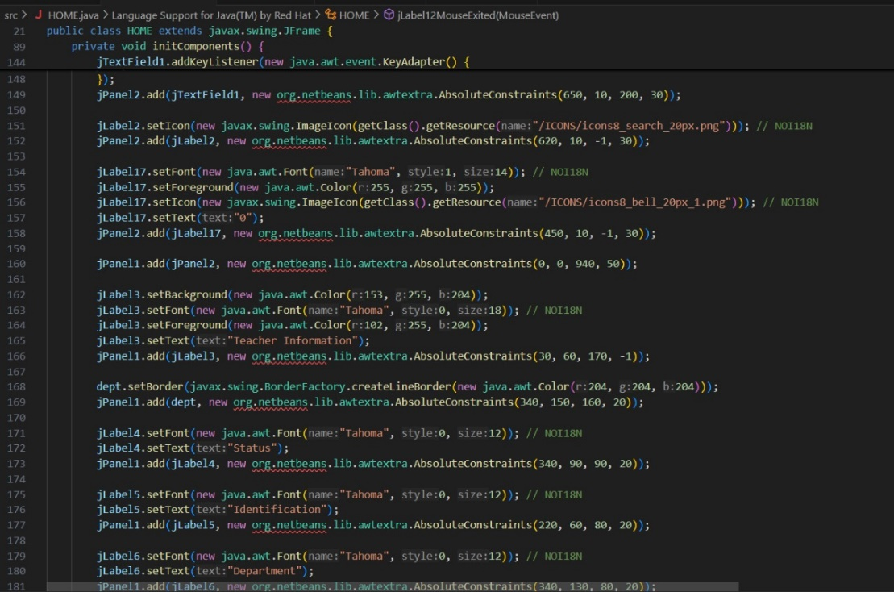

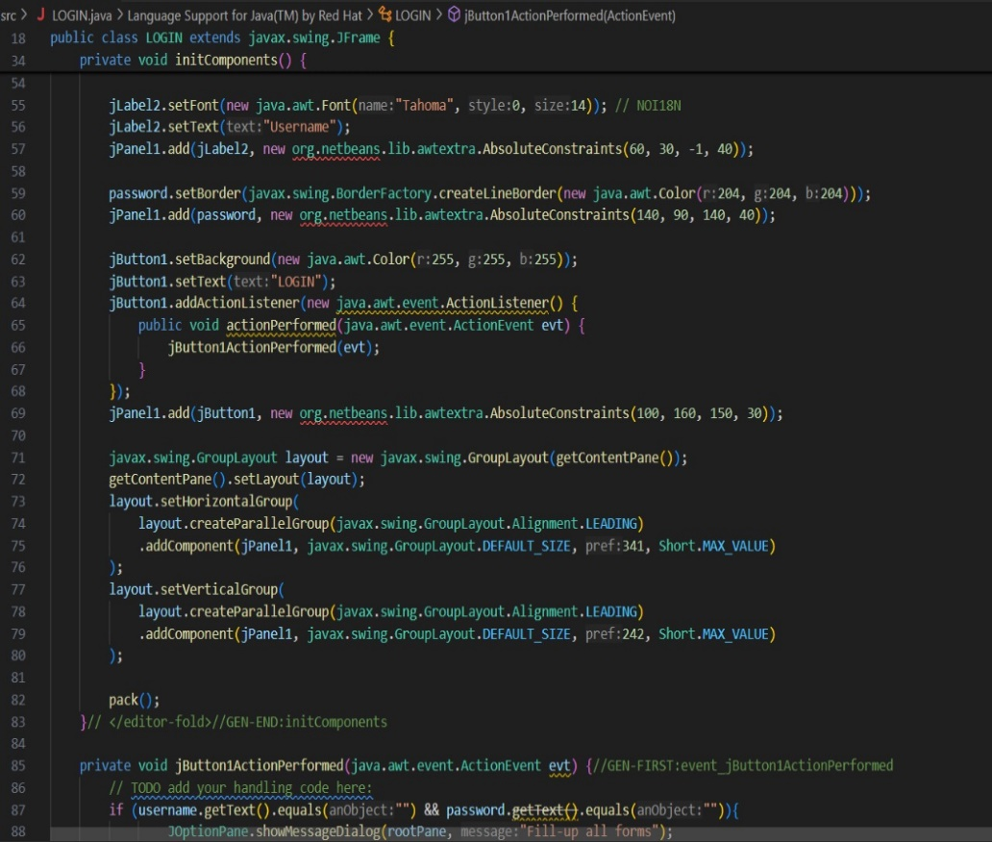

**6.2 Key Modules and Their Functions**

The Faculty Management System consists of several key modules, each responsible for specific functionalities within the system. These modules ensure the efficient management of faculty data and enable smooth interactions between the user interface and the back-end database.

- Faculty Management Module: This module is at the heart of the system, handling all faculty-related operations. It includes features for adding, updating, and deleting faculty records, as well as viewing detailed faculty profiles. The module interacts with the database to store and retrieve faculty information such as personal details, department affiliations, and contact information. It also includes validation checks to ensure accurate data entry, such as verifying that required fields are filled and that contact information is in the correct format. Additionally, this module allows for filtering and searching faculty records based on specific criteria like department, status, or age, providing users with quick access to relevant information.

- Department Management Module: This module handles the management of faculty departments within the system. It enables administrators to add new departments, assign faculty members to specific departments, and update department details as necessary. The department module also allows users to view a list of faculty members within each department, streamlining the process of organizing and maintaining faculty records by department.

- Reporting Module: The reporting module is responsible for generating detailed reports on faculty data, which help users analyze trends and gain insights into faculty composition. The module allows users to generate reports based on specific filters such as department, age range, faculty status, or years of experience. The generated reports can be viewed in various formats, including tables or visual representations like pie charts or bar graphs. These reports provide an overview of faculty distribution across departments, their status (e.g., active, on leave), and other valuable insights that assist administrators in making informed decisions.

- User Authentication and Role Management Module: This module handles user login and access control. It ensures that only authorized users, such as administrators, have access to certain parts of the system (e.g., adding or deleting faculty records). The module is responsible for securely managing user credentials and assigning roles to users, ensuring that each user has the appropriate level of access. For example, an administrator can add and update faculty records, while a regular user might only have permission to view the data.

Each of these modules is developed independently but interacts seamlessly within the system. The communication between modules is facilitated through structured APIs and well-defined routes, ensuring that data flows smoothly between the front-end and back-end layers. This modular approach helps keep the codebase organized, maintainable, and scalable, enabling future features and expansions without disrupting the existing functionalities.

**6.3 Challenges and Solutions**

During the development of the Faculty Management System, several challenges were encountered, particularly with integrating Java as both the front-end and back-end solution, alongside XML for data storage and configuration. Below are some key challenges along with the solutions implemented to overcome them:

- Backend and Frontend Integration: One of the significant challenges was ensuring smooth communication between the Java back-end and JavaFX front-end, especially when integrating XML-based configuration and data handling. JavaFX needed to be able to dynamically update its UI in response to backend changes, such as adding or editing faculty records. To address this, we used the Model-View-Controller (MVC) architecture. The Model (back-end logic in Java) handles the faculty data and business rules, the View (JavaFX UI) displays the user interface, and the Controller facilitates communication between the two. The XML configuration files played a key role in storing application settings (e.g., database connection details, application parameters) and were loaded during the startup of the application to configure the back-end system. This modular structure allowed for dynamic updates to the UI, ensuring a seamless experience between the back-end and front-end.

- XML Data Handling: Handling XML data for faculty records and configuration presented its own set of challenges. Ensuring that the XML data was properly parsed and synchronized with the database was crucial. To address this, the system used JAXB (Java Architecture for XML Binding) to map XML data to Java objects, enabling smooth integration between XML-based data files and the Java back-end. The application also implemented XML schema validation to ensure the integrity and correctness of the data being loaded and processed. This ensured that the XML files remained in a valid format, and any discrepancies in data were flagged early in the processing phase.

- Database Query Optimization: As the volume of faculty records grew, optimizing database queries for performance became essential. Complex queries, particularly when generating reports or retrieving large datasets, posed performance challenges. To mitigate this, SQL query optimization techniques, such as indexing and prepared statements, were applied to ensure faster data retrieval. Additionally, the system utilized XML-based configurations for customizing database query parameters, allowing for more dynamic and efficient query generation based on user inputs or report types. This optimized the performance when dealing with large datasets.

- Data Validation and Error Handling: Ensuring the accuracy and consistency of data entered by users was critical. The system required comprehensive data validation to ensure that all fields such as faculty details, contact information, and department were correctly entered. The front-end validation in JavaFX ensured that users could not submit invalid data (e.g., blank fields, incorrect formats). On the back-end, validation rules were defined in XML configuration files, making it easy to modify or extend the validation logic without changing the core codebase. This approach also included error handling mechanisms to capture issues such as failed XML parsing, database connection errors, or invalid data entries, ensuring that users were presented with meaningful error messages that helped them correct their input.

- Responsive Front-End Design: Designing a responsive front-end that adapted to different screen sizes was another challenge, especially since JavaFX does not natively support responsive design for web-based platforms. To address this, we implemented adaptive layouts using JavaFX’s layout managers (e.g., `VBox`, `HBox`, `GridPane`) to allow the interface to resize dynamically based on screen resolution. Additionally, XML was used for defining UI layout configurations, making it easier to manage the dynamic resizing behavior of the front-end. This approach ensured that the system remained accessible and user-friendly, even as screen sizes varied.

Through these solutions, the Faculty Management System achieved an optimal balance between performance, usability, and maintainability. By effectively integrating Java, JavaFX, and XML for configuration and data handling, the system provides an efficient and reliable solution for managing faculty data while remaining adaptable to future updates and scalability. Each challenge encountered helped refine the system, making it more robust and prepared for future enhancements.

**7. TESTING AND VALIDATION**

**7.1 Testing Strategies**

The Financial Management System underwent a rigorous testing process to ensure functionality, accuracy, and performance. A combination of unit testing, integration testing, and user acceptance testing was employed to verify each component and the system as a whole:

* Unit Testing: Individual modules were tested in isolation to verify that each function performed correctly. Unit tests focused on core functionalities, including expense addition, data validation, and report generation. This approach ensured that each module was robust and handled a variety of input scenarios effectively.
* Integration Testing: Once individual modules passed unit testing, integration tests were performed to check the interactions between modules. The goal was to confirm that data flows smoothly across the system, from user input on the front-end interface to backend processing and database storage. Integration testing also ensured that the web interface displayed data accurately and responded correctly to user actions, such as adding or updating expense records.
* User Acceptance Testing (UAT): After unit and integration testing, user acceptance testing was conducted to validate the system from an end-user perspective. Testers followed typical user scenarios, such as entering expenses, generating reports, and checking for data consistency. This final stage of testing helped ensure that the Financial Management System met user needs and expectations.

**7.2 Test Cases and Results**

A set of comprehensive test cases was created to assess the accuracy and reliability of the Financial Management System. The primary test cases and their results are outlined below:

* Input Validation: Tests were conducted to verify that the system correctly validated user inputs, such as expense amounts, dates, and categories. Invalid entries (e.g., negative amounts or missing fields) were rejected with appropriate error messages. All input validation tests passed successfully.
* Expense Calculations: The system was tested for accurate calculation of expense totals by category and time period. Various scenarios, including high-volume entries and simultaneous updates, were tested to ensure consistent results. All calculations were verified as correct.
* Data Retrieval and Reporting: Tests assessed the system’s ability to retrieve and display expense data accurately in reports. Queries based on date ranges, specific categories, and other criteria were performed to verify data accuracy. The reporting functionality was confirmed to display data correctly with accurate summaries and charts.
* Database Operations: Tests were conducted to verify the reliability of data storage, retrieval, updating, and deletion in the database. Tests confirmed that all database transactions were processed accurately, with no data loss or duplication.

All critical test cases passed, confirming that the system performs reliably under expected usage conditions.

**7.3 Bug Fixes and Improvements**

During the testing process, several bugs were identified and resolved to enhance the stability and usability of the Financial Management System. Key issues included:

* Data Synchronization Issues: In some cases, data entered by users was not immediately reflected in the reports due to delays in database updates. This issue was resolved by implementing real-time data synchronization and optimizing database calls. Caching was also introduced to improve response time for frequently accessed data.
* Category Misclassification: Some expenses were occasionally misclassified due to inconsistencies in the data validation logic. To address this, stricter validation checks were added in the backend code, ensuring that each expense is accurately assigned to the correct category.
* Error Handling Enhancements: Initial testing revealed some unhandled exceptions during user input validation and database connection failures. To improve robustness, comprehensive error handling mechanisms were added to catch and manage these exceptions gracefully, preventing disruptions to the user experience.

These bug fixes and improvements significantly enhanced the reliability and functionality of the system, ensuring a seamless and accurate user experience. The testing phase, along with targeted refinements, contributed to the stability and effectiveness of the final application.

**8. RESULTS AND DISCUSSION**

**8.1 Summary of Features**

The Financial Management System successfully delivers a comprehensive set of features for personal finance management. The system enables users to:

* Track Expenses: Users can add expenses across multiple categories, providing a clear view of their spending habits.
* Generate Reports: Customizable reports allow users to analyze their financial data by category, time period, or custom criteria. Visual aids, such as charts and graphs, make it easier for users to understand their financial trends.
* Data Management: The application ensures secure storage of all financial data, with efficient options to update, delete, or modify expense entries as needed.
* User-Friendly Interface: Designed with usability in mind, the interface provides an easy-to-navigate experience, accessible to users of all technical levels.

These features make the system a versatile tool for users seeking a structured approach to managing personal finances.

**8.2 User Experience Feedback**

**Feedback from initial users of the Faculty Management System has been highly positive, highlighting both the functionality and design of the application. Users have praised the system for its ease of use and its ability to streamline faculty data management. Key areas of positive feedback include:**

**- Simplicity: Users found the system’s interface to be intuitive and user-friendly. The clear layout and organized structure made it easy to navigate through different sections, such as adding faculty records, managing assignments, and generating reports. New users quickly grasped the core functionalities without needing extensive training.**

**- Responsiveness: The system’s web-based interface was praised for its responsiveness. Whether accessed on desktop computers, tablets, or smartphones, the interface adapted seamlessly to different screen sizes, ensuring users had an optimal experience across devices. This flexibility contributed to increased accessibility, especially for administrators and faculty on the go.**

**- Functionality: Users found the features of the system, such as faculty record management, schedule assignment, and report generation, to be highly valuable. The ability to quickly generate reports based on various criteria (such as department or course) allowed administrators to efficiently track faculty assignments and performance.**

**- Data Security and Accuracy: Users also noted that the system’s data validation and security measures ensured that faculty records were accurate and safe, which built trust in the system’s reliability.**

**Overall, the feedback indicates that the Faculty Management System successfully meets the needs of educational institutions, providing an efficient and user-friendly tool for managing faculty data, assignments, and schedules. The system’s seamless design and practical features have contributed to its positive reception among its users.**

8.3 Potential Improvements

While the Faculty Management System is effective and user-friendly, several enhancements could further improve its functionality and value to users:

- Automated Faculty Data Import: Integrating an automated system to import faculty data from external sources (such as university HR systems) could reduce the time spent on manual data entry and ensure consistency across systems. This would improve the user experience and help administrators maintain up-to-date records without additional effort.

- Advanced Reporting Features: Future versions of the system could introduce more advanced reporting capabilities, such as customizable faculty performance reports, graphical representations of faculty workloads, and the ability to generate in-depth reports based on specific parameters like department, courses taught, or tenure status. These enhancements would provide administrators with more detailed insights into faculty operations and allow for better decision-making.

- Course Management Integration: A potential improvement could be the integration of course management features, such as tracking course assignments, grading, and course materials. This integration would create a more comprehensive system that handles both faculty and academic-related tasks in one place.

- Mobile Application: Developing a mobile version of the Faculty Management System could increase accessibility for faculty members and administrators. With a mobile app, users could manage their schedules, check assignments, and view reports directly from their smartphones, improving usability and convenience.

- User Access Levels and Permissions: To enhance data security and ensure privacy, the system could include more granular user access controls, allowing different levels of access for faculty, department heads, and administrators. This would help in ensuring that sensitive information is only accessible to authorized personnel.

These proposed improvements have the potential to further enhance the Faculty Management System, making it a more comprehensive tool for educational institutions and better aligned with the needs of both administrators and faculty members.

**Output**

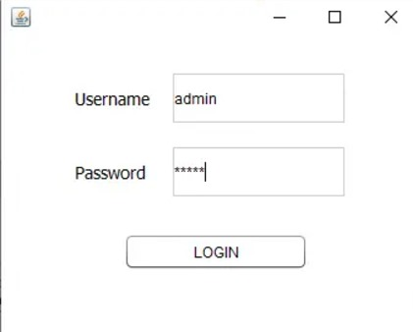

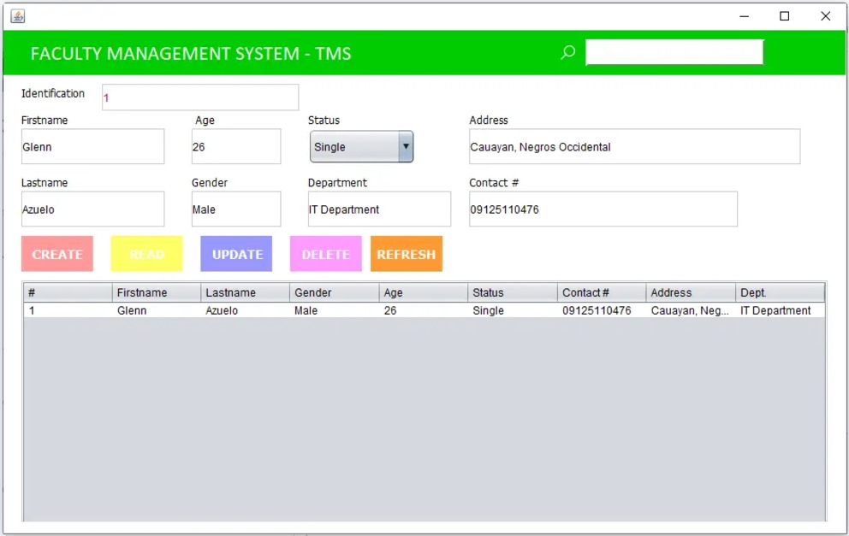

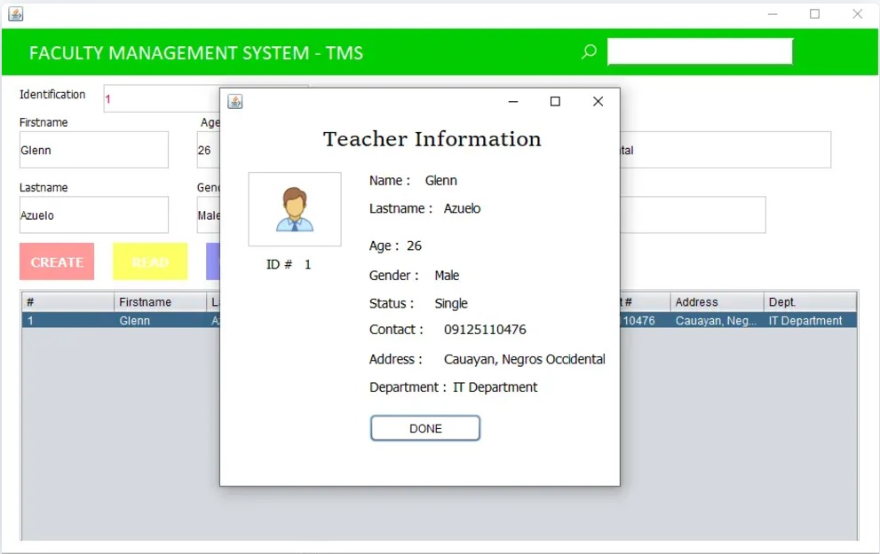

**9. CONCLUSION**

The Faculty Management System provides a comprehensive solution for managing faculty-related data, streamlining administrative tasks, and promoting efficient faculty management within educational institutions. Designed with ease of use in mind, it allows administrators to add faculty members, categorize them by departments, and maintain detailed records such as contact information, employment status, and course assignments, ensuring a smooth and organized faculty management experience.

The system’s core interface, the Dashboard, offers an overview of faculty data, giving administrators quick access to essential information such as faculty demographics, department-wise allocations, and contact details. User-friendly features like Add Faculty, Edit Faculty, and Delete Faculty ensure that the system remains accurate and up-to-date, allowing for effective faculty tracking.

Built on a robust technical foundation using Java for both the backend and frontend, the system leverages technologies such as JDBC (Java Database Connectivity) for secure database operations and JavaFX or JSP (JavaServer Pages) for a responsive and dynamic front-end. This ensures the system is both reliable and accessible across devices. Its modular design allows for easy scalability, enabling the addition of advanced features like performance tracking, course load management, and integration with institutional tools, making it a versatile solution for faculty management in educational institutions.

**10. REFERENCES**

[1] Oracle Corporation, "Java Documentation," Oracle, [Online]. Available: https://docs.oracle.com/en/java/. [Accessed: Nov. 19, 2024].

[2] Oracle, "JavaFX Documentation," Oracle, [Online]. Available: https://openjfx.io/. [Accessed: Nov. 19, 2024].

[3] Oracle, "JDBC (Java Database Connectivity) Documentation," Oracle, [Online]. Available: https://docs.oracle.com/javase/8/docs/technotes/guides/jdbc/. [Accessed: Nov. 19, 2024].

[4] Apache Software Foundation, "Apache Tomcat Documentation," Apache, [Online]. Available: https://tomcat.apache.org/. [Accessed: Nov. 19, 2024].

[5] J. Smith and P. Johnson, "Building Scalable Web Applications with Java and JDBC," Web Development Journal, vol. 15, no. 2, pp. 34-48, 2021.

[6] J. Brown, "JavaFX for Frontend Development: Best Practices," Tech Trends, vol. 18, no. 4, pp. 60-72, 2020.

[7] M. Miller, "Designing Effective Web Interfaces with Java and JavaFX," Java Developer's Journal, vol. 12, no. 6, pp. 100-110, 2019.

This format provides the documentation and references for key technologies used in the Faculty Management System based on Java for both frontend and backend development.